# INTRODUCTION

* 1. 1.1 Overview

This process for helping implementing CRM for result tracking of a candidate with internal marks.

* 1. 1.2 Purpose

The use of this implementing a CRM system is a value ­­­- adding process that can bring great benefits to any business sales force. The ultimate goal is to improve communication and interaction with real customers and leads sales force.

1. **Problem Definition & Design Thinking**
   1. Empathy Map:
   2. An empathy map is a collaborative tool teams can use to gain a deeper insight in to their customers in sales force.

Paste the empathy map screenshot:

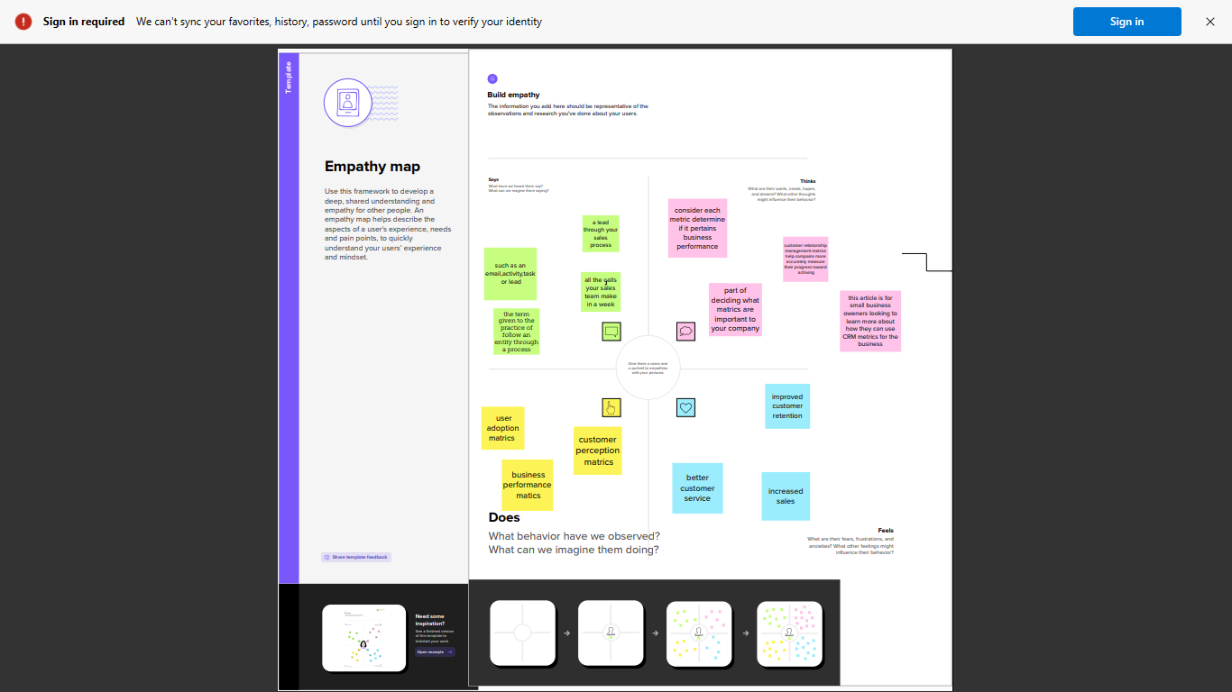

* 1. Ideation & Brainstorming Map :
  2. A mind map is a great tool for brainstorming new ideas . its unstructured format allows ideas and thoughts to flow freely . since concepts are placed in groupings.

Paste the Ideation & brainstorming map screenshot :

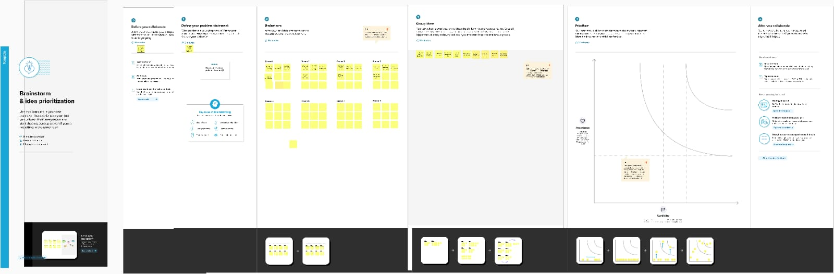

# RESULT

* 1. Data Model:

|  |  |
| --- | --- |
| Field label | Data type |
|  |  |
|  |  |

|  |  |
| --- | --- |
| **Object name** | **Fields in the Object** |
| semester | |  |  | | --- | --- | | Field label | Data type | | semester | Text(10) | | Semester name | Text(80) | |
| Candidate | |  |  | | --- | --- | | Field label | Data type | | Candidate | Text(12) | | Candidate name | Text(80) | |
| Course details | |  |  | | --- | --- | | Field Label | Data Type | | Course details | Text(14) | | Course details name | Text(80) | |
| Lecturer details | |  |  | | --- | --- | | Field label | Data type | | Lecturer details | Text(16) | | Lecturer details name | Text(80) | |
| Internal result | |  |  | | --- | --- | | Field label | Data type | | Internal result | Text(18) | | Internal result name | Text(80) | |

# Activity & Screenshot

Milestone 1:Creation Salesforce Org:

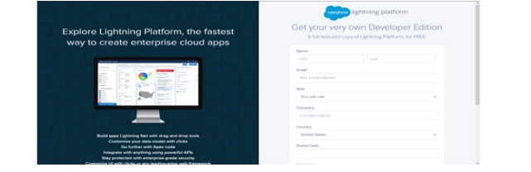.

Activity 1:

1.Go to developers.salesforce.com/

2. Click on sign up.

3. On the sign up form, enter the following details :

a. First name & Last name

a. Email

b. Role : Developer

c. Company : College Name

d. County : India

e. Postal Code : pin code

f. Username : should be a combination of your name and company This need not be an actual email id, you can give anything in the format : [username@organization.com](mailto:username@organization.com)

Milestone-2:Object

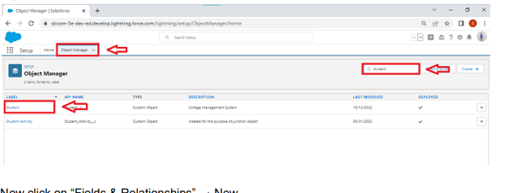

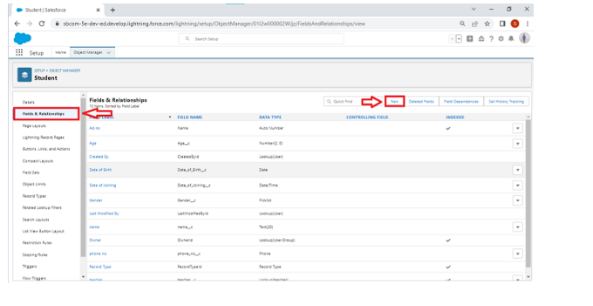

Activity-1:

Creation of fields:

● Click the gear icon and select Setup. This launches Setup in a new tab.

● Click the Object Manager tab next to Home.

● Select Semester.

● Select Fields & Relationships from the left navigation, and click New Now ready to make a custom field. Let's do this!

● Select the Text as the Data Type, then click Next.

● For Field Label, Enter Semester Name.

● Click Next, Next, then Save

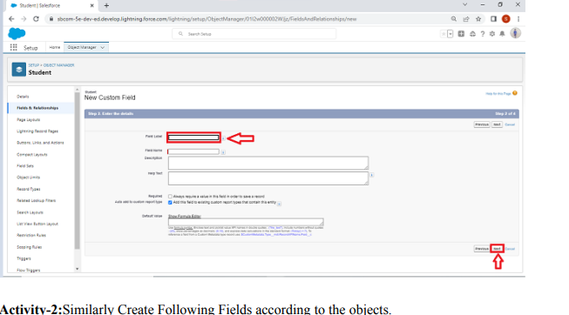

Activity-2:Similarly Create Following Fields according to the objects.

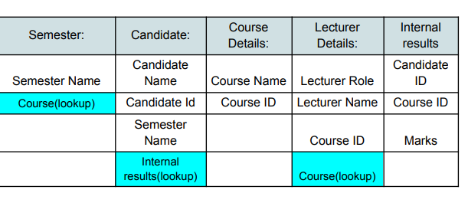

Milestone-3:Lightning App

Create the Candidate Internal Result Card app:

● From Setup, enter App Manager in the Quick Find and select App Manager.

● Click New Lightning App. Enter Candidate Internal Result Card as the App Name, then click Next

● Under App Options, leave the default selections and click Next.

● Under Utility Items, leave as is and click Next.

● From Available Items, select Semester,Candidate,Course Details,LecturerDetails,InternalResults and move them to Selected Items. Click Next.

● From Available Profiles, select System Administrator and move it to Selected Profiles. Click Save & Finish.

● To verify your changes,

click the App Launcher, type Candidate Internal Result Card and select the Candidate Internal Result Card app. To create a lightning app page: Go to setup page → search “app manager” in quick find → select “app manager” → click on

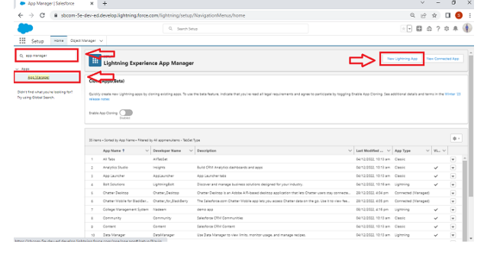 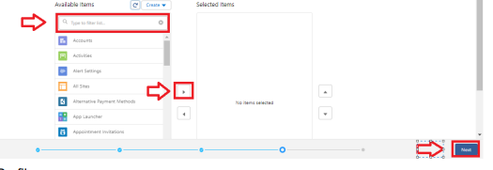

Milestone-4: Users

Activity 1: Creating a Users:

1. From Setup, in the Quick Find box, enter Users, and then select Users.

2. Click New User.

3. Enter the user’s name John Martin and (Your) email address and a unique username in the form of an email address. By default, the username is the same as the email address. 4. Select a Role(none)

5. Select a User Licence As salesforce.

6. Select a profile as Salesforce User.

7. Check Generate new password and notify the user immediately to have the user’s login name and a temporary password emailed to your email

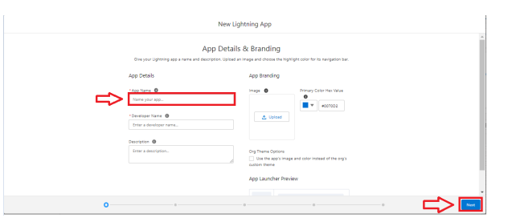

Milestone-5:Reports

Activity 1: Reports and dashboards:

1. From the Reports tab, click New Report.

2. Select the report type as Candidate with candidate Marks for the report, and click Create.

3. Customise your report, then save or run it.

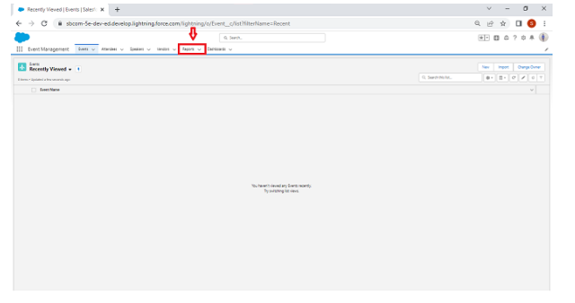

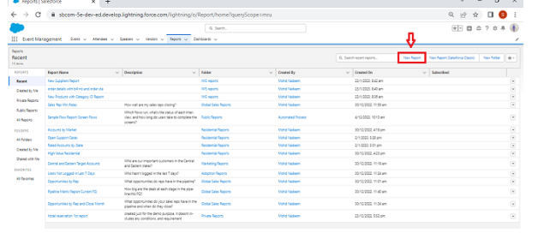

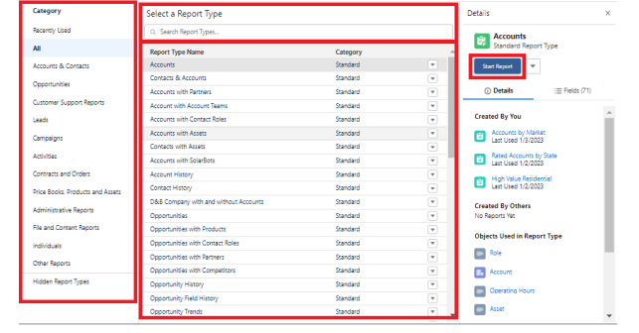

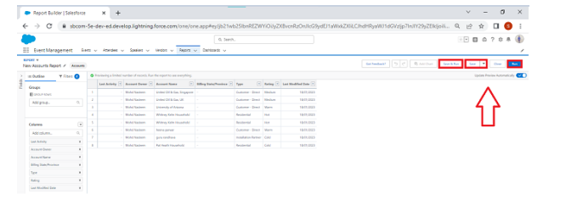

Milestone-6:Dashboards:

Activity 1: Create a Dashboard:

1. Click the Dashboards tab

2. Click New Dashboard.

3. Name your dashboard Candidate Board . Leave all other fields as is and click Create.

4. Click + Component.

5. For Report, select Candidate Marksby Stage. Click Select. ...

6. For Display As, select Vertical Bar Chart and click Add.

7. Click Save.

8. Click Done

# Trailhead Profile Public URL

**Team Lead - trailblazer.me/id/suvetha2003**

**Team Member1-trailblazer.me/id/srinithi2002**

**Team Member2-trailblazer.me/id/rekaa1**

# Team Member3-trailblazer.me/id/sindhiya2003

# Team Member4-trailblazer.me/id/gokul2002

# 

1. **ADVANTAGES & DISADVANTAGE**

* Customer experience may worsen due to staff over reliance on the system.
* The excess initial time and productivity cost at the implementation.
* Security and date protection issues with centralised data.

APPLICATIONS:

Sales force unites your marketing sales, commerce, service, and it terms from anywhere with customer 360 one integrated CRM platform that powers our entire suite of connected.

# CONCLUSION

In this project we are explained about the topic implementing CRM for result tracking of a candidate with internal marks.

# FUTURE SCOPE:

* Customers will become a company’s best sales reps through superior products and services as well as customer oriented messaging.
* With over 150,000 organizations utilizing salesforce across the world to fuel their growth, it is the most popular and widely used CRM platform.